Cloud based health record exchange System Architecture

The proposed system is a cloud-hosted national health record exchange designed to replace paper-based patient booklets across Lesotho's primary and secondary health facilities. It utilizes a web-based architecture where authorized clinical staff access a centralized database via browsers or mobile apps. To ensure interoperability and scalability, the backend is built on modular, containerized microservices using international standards, while the frontend is designed for low-bandwidth environments with local caching and offline capabilities. Security is central to the design, incorporating encryption, role-based access controls, and data residency protocols. Refer to figure 1.1 on the next page
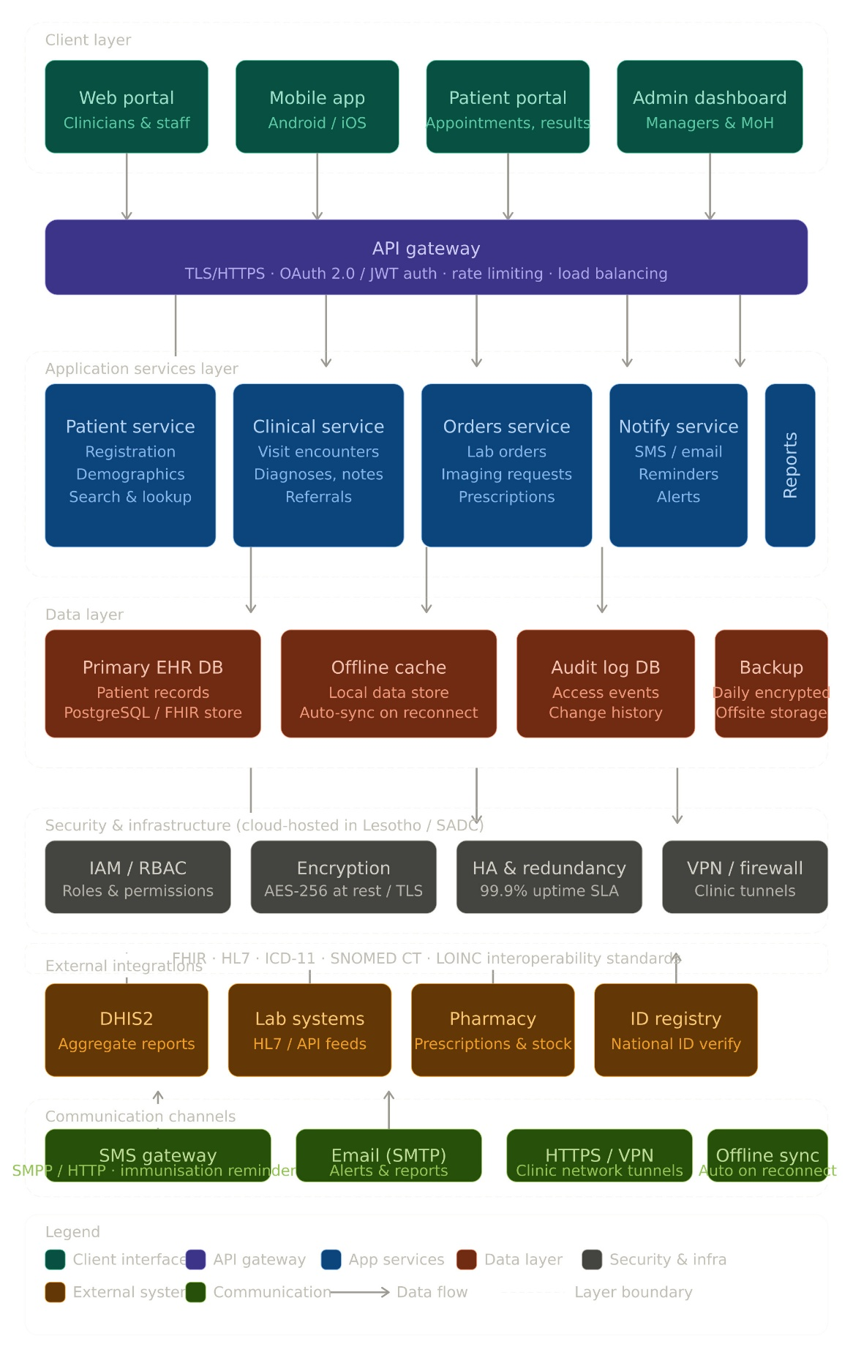
Fig 1.1

